Practical no.2

***Title: Frequency Polygon, Frequency Curve, Ogive Curve***

**Frequency Polygon:**

Polygon means a figure having more than four side. A frequency polygon is a figure in which frequency is taken on one of the axis the values of variables are taken on Y-axis. The point are then jointed by straight lines. Frequency polygons are a graphical method for understanding the shapes of distribution. They serve the same purpose as histograms, but are especially helpful for displaying **cumulative frequency distributions.**

***Stepwise Procedure:***

1. Insert data two columns namely class interval and class frequency.
2. Create column midpoint of class interval between C.I. and class frequency by using following formula. Name it as X;
$$Mid-Point=X= \frac{Upper Limit + Lower Limit}{2}$$

3. Select columns “X” and “Frequency”.
4. Go to “Insert menu → Chart → Scatter → Scatter with straight line → Click.
5. As out of step 4 we get frequency polygon. Give appropriate axis title and chart title by using usual procedure.

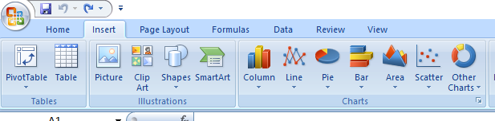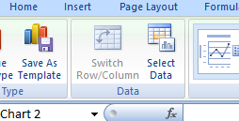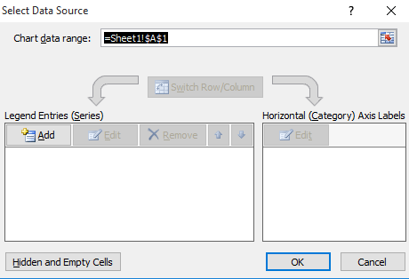

**Frequency Curve:**

A frequency curve is a smooth figure. It can be obtain by smoothing out the frequency polygon. A smooth curve which corresponds to the limiting case of a histogram computed for a frequency distribution of a continuous distribution as the number of data points becomes very large.

***Stepwise Procedure:***

1. Insert data two columns namely class interval and class frequency.
2. Create column midpoint of class interval between C.I. and class frequency by using following formula. Name it as X;
$$Mid-Point=X= \frac{Upper Limit + Lower Limit}{2}$$

3. Select columns “X” and “Frequency”.
4. Go to “Insert menu → Chart → Scatter → Scatter with smooth line → Click.
5. As out of step 4 we get frequency polygon. Give appropriate axis title and chart title by using usual procedure.

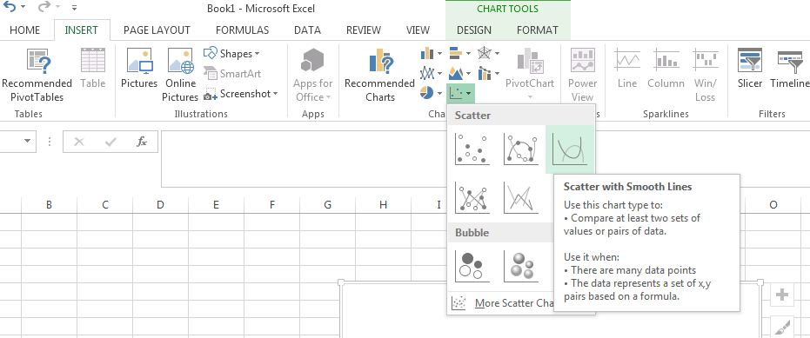

***Ogive Curve:***

An Ogive (Oh-jive), sometimes called a cumulative frequency polygon, is a type of frequency polygon that shows cumulative frequencies. In other words, the cumulative percent’s are added on the graph from left to right. An ogive graphs plots cumulative frequency on the Y-axis and class boundaries along the X-axis.

***Stepwise Procedure:***

1. Insert the classes, Frequencies, Lower limit of the first class and lastly add the Upper limit of the last class.
2. Consider one more lower class boundary of the class next to the last class with 0 frequency.
3. Select data in the column less than type cumulative frequency except last.
4. Insert menu → Chart scatter type chart→ Sub chart → Data range → Give a title, X-axis and Y-axis → Give labels (If necessary) → Finish.

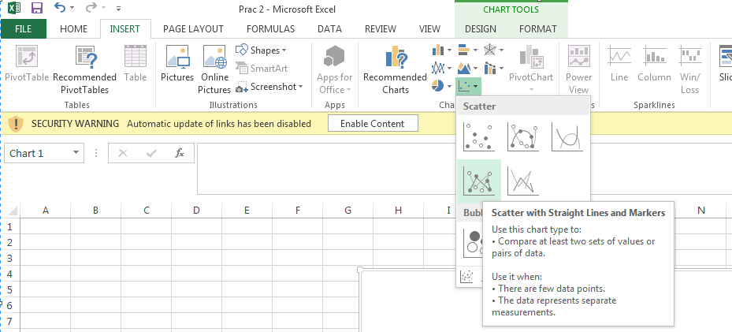

1. Right click on any one X-axis, click on select on select data, click on edit on series X values, select data in column upper class boundaries except last, Click on OK, Click on Add, Click on seriesX values, select data in the column lower class boundary except first, click on series Y-values, select data in column more than type cumulative frequency except first, Click on OK, Click on OK, both the Ogive curves intercept at Median.

**Histogram and Bar Chart:**

A histogram is used for continuous data, where the bins represent ranges of data, while a bar chart is a plot of categorical variables. Some authors recommend that bar charts have gaps between the rectangles to clarify the distinction. A frequency distribution shows how often each different value in a set of data occurs. A histogram is the most commonly used graph to show frequency distributions. It looks very much like a bar chart, but there are important differences between them.

***Stepwise Procedure:***

1. Select class interval and frequency column click on insert column and select appropriate column chart.
2. Since histogram is continuous chart, for graph we will have to remove the blank space between two successive columns of a chart.
3. To remove this space, right click on the column of the chart and select format data series.
4. In format data series window, in series option make the ‘gap width’ 0% and click on close.
5. Give the appropriate axis title and chart title by using layout menu bar.

**NOTE – 1:**

Frequency table with ungrouped classes is also referred as discrete frequency table and similarly a frequency table with grouped classes is referred as continuous frequency table.

**NOTE – 2:**

Frequency function in excel, always counts frequency of the observation – **‘bins’** in that current class. It means that frequency formula always gives frequency for inclusive type of class intervals.

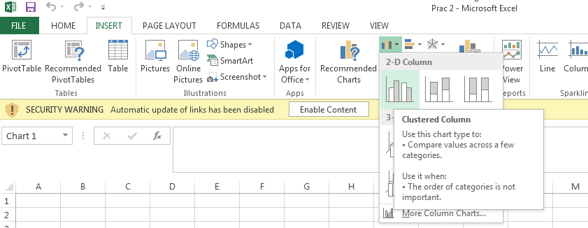

If you want to form exclusive type of class interval like 0-15, 15-30, 30-45, 45-60, 60-75, 75-90, you should select 14, 29, 44, 59,74, 89 as a ‘bins’ array for respective classes because number provided in bins array column is included in class frequency.

Similarly of you want form inclusive type of class interval like 0-15, 16-30, 31-45, 46-60, 61-75, 76-90 than you should select 15, 30, 45, 60, 75 in the **‘bins’** array for the respective classes

**Examples:**

1. Following is the data obtained from hospital. To know in which age group more Asthma patients. Then the investigator collects the information of 100 patients who were suffering from Asthma.

|  |  |  |  |  |  |  |  |  |  |  |
| --- | --- | --- | --- | --- | --- | --- | --- | --- | --- | --- |
| **Age Gr.** | 0-10 | 10-20 | 20-30 | 30-40 | 40-50 | 50-60 | 60-70 | 70-80 | 80-90 | 90-100 |
| **# Patients** | 2 | 8 | 6 | 10 | 18 | 16 | 17 | 13 | 8 | 2 |

1. Following is the data about drinkers in a specific age group in a village.

|  |  |  |  |  |  |  |  |  |
| --- | --- | --- | --- | --- | --- | --- | --- | --- |
| **Age group** | 10-20 | 20-30 | 30-40 | 40-50 | 50-60 | 60-70 | 70-80 | 80-90 |
| **# Drinkers** | 2 | 3 | 8 | 7 | 13 | 11 | 5 | 1 |

1. A random sample of 50 metal rings is taken to measure their weights (in gm) given as follow. Construct frequency distribution for this data with eight classes. What you observe from the frequency distribution of weights of metal ring? Construct ogive curve to find number of rings produced between weights 43 to 57 gm.

|  |  |  |  |  |  |  |  |  |  |  |  |  |  |  |  |  |
| --- | --- | --- | --- | --- | --- | --- | --- | --- | --- | --- | --- | --- | --- | --- | --- | --- |
| 51 | 53 | 52 | 63 | 62 | 44 | 57 | 53 | 57 | 52 | 49 | 44 | 57 | 58 | 39 | 42 | 47 |
| 53 | 44 | 41 | 46 | 43 | 49 | 56 | 42 | 47 | 38 | 43 | 46 | 53 | 51 | 55 | 50 | 50 |
| 41 | 46 | 54 | 50 | 47 | 57 | 56 | 52 | 44 | 51 | 53 | 52 | 55 | 69 | 42 | 36 |  |

1. The following data are shape roughly like a normal distribution. Construct a frequency distribution starting with the 10 as the lowest class beginning point and use a class width of 10.Construct a histogram & frequency polygon curve for this frequency distribution & observe the shape of normal distribution.

|  |  |  |  |  |  |  |  |  |
| --- | --- | --- | --- | --- | --- | --- | --- | --- |
| 61.4 | 81.6 | 71.1 | 56.8 | 77.4 | 47.5 | 53.3 | 60.5 | 38.1 |
| 27.3 | 47.9 | 74.1 | 60.1 | 58.1 | 63.9 | 71.6 | 32.5 | 76.4 |
| 26.4 | 73.4 | 48.9 | 52.9 | 32.1 | 46.8 | 58.6 | 61.7 | 46.8 |
| 37.4 | 54.6 | 60.2 | 60.5 | 54.9 | 67.9 | 57.3 | 55.1 | 19.9 |
| 30.4 | 65.1 | 54.8 | 55.6 | 32.7 | 19.1 | 87.8 | 48.2 | 27.3 |
| 40.1 | 52.7 | 32.5 | 35.3 | 39.1 |  |  |  |  |

1. Following are the data collected from the collage. To know the daily use Internet data (in MB).The investigator collects 105 students information and draw frequency table in given below.

|  |  |  |  |  |  |  |  |  |  |
| --- | --- | --- | --- | --- | --- | --- | --- | --- | --- |
| **Use of Data**  **(in MB)** | 0-100 | 100-200 | 200-300 | 300-400 | 400-500 | 500-600 | 600-700 | 700-800 | 800-900 |
| **# Students** | 10 | 20 | 30 | 10 | 9 | 8 | 7 | 6 | 5 |